18.51: The temperature of 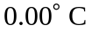 is just below the triple point of water, and so there will be no liquid. Solid ice and water vapor at 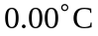 will be in equilibrium.

